Ormiston Academies Trust

(Academy Name)  
Anti-Fraud policy

Policy version control

|  |  |
| --- | --- |
| Policy type | OAT Mandatory |
| Author | Claire Lovell, OAT Finance |
| Approved by | Audit and Risk Committee, June 2023 |
| Release date | September 2023 |
| Review | Policies will be reviewed in line with OAT's internal policy schedule and/or updated when new legislation comes into force |
| Description of changes | * Reference to a zero-tolerance culture with regards to fraud * Reference to the fact that the Audit and Risk Committee have specific responsibilities with regards to fraud * Registers of interest should be completed by 30th October each year. * Inclusion of a Fraud Response Plan at Appendix 1 |

Contents

1. Introduction 3

2. Fraud 3

3. Policy statement 4

4. Roles and Responsibilities: 5

4.1. Staff and Governors 5

4.2. Internal Auditors 5

4.3. National Director of Finance and Finance Director 6

4.4. External Auditors 6

5. Confidentiality and Safeguards 6

6. Links with other Policies 7

Appendix 1 8

Fraud response plan 8

Appendix – flowcharts 11

Appendix A 12

Appendix B – Fraud flow chart 13

Appendix C – Procurement card flow chart 14

1. Introduction
   1. This policy and procedure defines the expected conduct of all staff engaged at the academy, whether in paid or voluntary employment, in relation to deterring and/or detecting fraud, and who to report it to. Reference is also made to other academy policies where appropriate.
   2. Ormiston Academies Trust (OAT) is committed to ensuring that it acts with integrity and has high standards of personal conduct. Everyone involved with the academy has a responsibility in respect of preventing and detecting fraud. All staff and governors have a role to play. The academy also recognises the role of others in alerting them to areas where there is suspicion of fraud. The Trust has a zero tolerance culture to all types of fraud, bribery and corruption.
   3. Recognising a potential fraud and being able to report it is just as important as the measures to prevent and detect.
   4. It is the duty of all employees and governors at the academy to take reasonable steps to limit the possibility of corrupt practices, and it is the responsibility of the internal auditors and the external auditors to review the adequacy of the measures taken by the academy to test compliance and to draw attention to any weaknesses or omissions.
   5. Any investigation carried out in relation to alleged irregularities is linked to the academy's disciplinary procedure.
2. Fraud
   1. Fraud is a general term covering theft, deliberate misuse or misappropriation of assets or anything that leads to a financial advantage to the perpetrator or others upon whose behalf he or she acts, even if these “others” are in ignorance of the fraud. Fraud is in fact intentional deceit and for this reason it cannot include negligence.
   2. Fraud incorporates theft, larceny, embezzlement, fraudulent conversion, false pretences, forgery, corrupt practices and falsification of accounts.
   3. Irregularities fall within the following broad categories, the first three of which are criminal offences:
      1. Theft - the dishonest taking of property belonging to another person with the intention of depriving the owner permanently of its possession;
      2. Fraud - the intentional distortion of financial statements or other records by persons internal and external to the academy, which is carried out to conceal the misappropriation of assets or otherwise for gain;
      3. Bribery and corruption (as covered in the gifts and hospitality policy)- involves the offering or the acceptance of a reward, for performing an act, or for failing to perform an act, which leads to gain for the person offering the inducement:
      4. Failure to observe, or breaches of, scheme of delegation and financial regulations within the academy's procedures which in some circumstances can constitute an irregularity, with potentially significant financial consequences.
      5. Phishing fraud – this is where fraudsters access valuable personal details such as usernames and passwords, and can involve sending malicious attachments or website links in an attempt to infect computers or mobile devices. For further details on phishing and for advise on what to do following a possible phishing fraud please refer to the Cyber Strategy.
      6. Examples of what could constitute fraud and corruption are:
      * theft of cash;
      * non-receipt of income;
      * substitution of personal cheques for cash;
      * travelling and subsistence claims for non-existent journeys/events;
      * travelling and subsistence claims inflated;
      * data fraud – please refer to the data protection policy
      * manipulating documentation to increase salaries/wages received, e.g. false overtime claims;
      * payment of invoices for goods received by an individual rather than the academy;
      * failure to observe, or breaches of, regulations and/or other associated legislation laid down by the academy;
      * unauthorised borrowing of equipment;
      * breaches of confidentiality regarding information;
      * failure to declare a direct pecuniary or otherwise conflicting interest;
      * concealing a generous gift or reward;
      * unfairly influencing the award of a contract;
      * creation of false documents;
      * deception;
      * using position for personal reward.
   4. The above list is not exhaustive and fraud and corruption can take many different paths. If in any doubt about whether a matter is an irregularity or not, clarification must be sought from the Head of Compliance and Reporting.
   5. Similarly, if there is concern or doubt about any aspect of a matter which involves an irregularity, or an ongoing investigation into a suspected irregularity, the best approach is to seek advice from the Principal and the Head of Compliance and Reporting.
3. Policy statement
   1. This policy and procedure defines anti-fraud and offers guidance for all staff in the academy.
   2. The Trust aims to be an honest and ethical institution. As such, it is opposed to fraud and seeks to eliminate fraud by the way it conducts academy business. This document sets out the academy's policy and procedures for dealing with the risk of significant fraud. In order to minimise the risk and impact of fraud, the academy's objectives are, firstly, to create a culture which deters fraudulent activity, encourages its prevention and promotes its detection and reporting and, secondly, to identify and document its response to cases of fraud practices.
   3. This policy, in line with the Trust’s corporate values and best practice, provides both staff and management with mutually understood guidelines for the administration of this procedure.
   4. The scope of this procedure extends to all academy employees, permanent, voluntary and fixed term.
   5. Time limits specified in this document may be extended by mutual agreement.
   6. If requested, employees may be accompanied by a recognised trade union representative or work colleague, not involved in any part of the process, at any interviews.
4. Roles and Responsibilities:
   1. Staff and Governors
      1. The Trust has adopted the following measures to demonstrate its commitment to anti-fraud and corruption:
         1. All boards and committees meet regularly. The Audit and Risk Committee have specific responsibility for fraud.
         2. A requirement for all staff and governors to declare prejudicial interests and not contribute to business related to that interest, these should be completed by 30th October each year.
         3. A requirement for staff and governors to disclose personal interests by 30th October each year.
         4. Clear recruitment policies and procedures.
      2. Staff and governors also have a duty to report another member of staff or governor whose conduct is reasonably believed to represent a failure to comply with the above.
   2. Internal Auditors
      1. The internal auditors have specific responsibility for overseeing the financial arrangements on behalf of the governors.
      2. Some of the main duties of the internal auditors are to provide the governors with on-going independent assurance that:
         1. The financial responsibilities of the governors are being properly discharged;
         2. The resources are being managed in an efficient, economical and effective manner;
         3. Sound systems of financial control are being maintained; and
         4. Financial considerations are fully taken into account in reaching decisions.
   3. National Director of Finance and Finance Director
      1. The National Director of Finance is ultimately responsible for ensuring that effective systems of internal controls are maintained throughout the Trust. The individual finance leads ensure that they are followed at the academy and they also will safeguard the resources of the academy.
      2. In respect of fraud it is the responsibility of the National Director of Finance to ensure internal controls prevent and detect any frauds promptly. The individual finance leads will then ensure that these are internal controls are in place at the academy and that appropriate segregation of duties are maintained at all times.
      3. It therefore needs to be ensured that the following are in place:
         1. Proper procedures and financial systems;
         2. Effective management of financial records;
         3. Management of the academy’s financial position.
   4. External Auditors
      1. The academy’s annual report and financial statements include an independent auditors’ report. This report includes a view as to whether the financial statements give a true and fair view and whether proper accounting records have been kept by the academy throughout the financial year. In addition, it reports on compliance with the accounting requirements of the relevant companies act and confirms compliance with the financial reporting and annual accounting requirements issued by the Department of Education.
5. Confidentiality and Safeguards
   1. OAT recognises that the decision to report a concern can be a difficult one to make, not least because of the fear of reprisal from those responsible for the alleged malpractice. The academy will not tolerate harassment or victimisation and will do what it lawfully can to protect an individual when a concern is raised in good faith.
   2. This does not mean that if the person raising the concern is already the subject of a disciplinary, redundancy or other procedure, that those procedures will be halted as a result of the concern being reported.
   3. There is a need to ensure that the process is not misused. For further guidance refer to the staff disciplinary policy.
6. Links with other Policies
   1. The governing board is committed to preventing fraud and corruption. To help achieve this objective there is a clear network of systems and procedures in place for the prevention, detection and investigation of fraud and corruption. This anti-fraud policy attempts to consolidate those in one document and should be read in conjunction with the following academy policies:
      1. Whistle-Blowing Policy
      2. Financial Regulations
      3. Staff Disciplinary Policy
      4. Equality Policy
      5. Data protection policy
      6. Gifts and Hospitality Policy

Appendix 1

Fraud response plan

The purpose of this fraud response plan is to provide a formal framework that individuals within the Trust are able to follow in the event of a suspected fraud. Those investing a suspected fraud should be able to:

* Establish the facts around the suspected fraud as efficiently as possible to ensure that effective action is taken to prevent any future losses,
* Improve the likelihood and scale of recoveries
* Identify the individuals concerned without initially raising suspicion and then taking appropriate action against these individuals
* Report as necessary to the relevant bodies.
* Re emphasize that the Trust has a zero-tolerance culture to fraud

Reporting a Suspected Fraud

All members of staff, students and the local governing body may be in a position to suspect fraud at an academy or at head office. If a suspected fraud is identified at an academy, all allegations must be brought to the attention of the Finance Director and the Principal, unless this individual is involved in the irregularity in which case the Chair of Governors should be informed. If a fraud is suspected at head office the National Director of Finance and Strategy should be informed. If the fraud involves this individual the Chair of Trustees should be informed.

If a suspected fraud is observed and it is not reported in accordance with this policy, this may also result in disciplinary procedures on the individuals for not following the correct reporting lines.

Individuals who report the fraud should provide as much detail as possible to enable the initial investigations to start, whilst at the same time ensuring that their actions do not raise the suspicion of the individuals in question.

If the suspected fraud is from an external party, such as a supplier fraud, please refer to the Mandate Fraud Policy in the first instance and the flow charts at the end of this policy.

If there is another type of external fraud please refer to your Head of Academy Finance and your HO team, who will take the necessary steps to inform the relevant individuals.

If the fraud relates to a potential data breach, please follow the data protection policy for further guidelines.

Response to Allegations

The Principal will have responsibility for coordinating the initial response. In doing this he/she will consult with the human resource advisors regarding potential employment issues. The Principal will also seek legal advice from the academy’s solicitors on both employment and litigation issues before taking any further action.

The Finance Director and Principal will ascertain whether or not the suspicions aroused have substance. In every case, and as soon as possible after the initial investigation, they will pass the matter on to the Chair of the local governing body (LGB) Even if there is no evidence to support the allegation, the matter must be reported. This must be done within 24 hours of the initial suspicions being raised.

The Principal is required to notify the LGB of any serious financial irregularities. This action must be taken at the first opportunity following the completion of the initial investigations and will involve keeping the chair of the governing board fully informed between governor meetings of any developments relating to serious control weaknesses, fraud or major accounting breakdowns.

The LGB will undertake the management of the investigation. They will, if appropriate, conduct a preliminary investigation to gather factual information and reach an initial view as to whether further action is required. If further investigations are required, they will determine which outside agencies should be involved (police, auditors). At this point if further investigations are required the Chair of the LGB will inform the National Director of Finance and Strategy.

The Chair of the LGB will also keep in close contact with the HR team at head office to determine if any disciplinary procedures need to be followed, and if required these will be led by HR and will progress with the investigation.

Prevention of Further Loss

Where the investigation provides a reasonable ground for suspecting a member of staff or others or fraud, the investigating team will need to decide on how to prevent further loss. This may involve liaising with HR and under the appropriate disciplinary procedure suspending the individual. This will need careful consideration to ensure that the suspect does not become aware of the investigation so only the individuals involved in the main investigation need to be aware of this plan of action.

If the individual concerned needs to be suspended they should be supervised at all times before leaving the academy. They should be allowed to collect personal equipment, but all passes and keys will need to be returned to the academy.

The ICT team should also be informed so as to ensure that access rights are stopped to all of the academy’s computer systems.

Securing Evidence

All information should be fully documented from the date that the initial fraud was suspected. Written notes should cover at least the following areas:

-Name, address and DOB of all individuals involved in the investigation

-Dates and times of key events

-Details of all conversations or incidents that were observed

- Any other data relevant to the case such as telephone numbers, car registrations, bank accounts etc

Any physical evidence such as invoices, receipts or printed emails should be secured in a lockable safe and should be handled by as few people as possible.

Progress

The LBG should prepare regular reports informing the National Director of Finance and Strategy of the progress of their investigation, on at least a weekly basis following the start of the investigation.

This should include progress with regards to recovery of funds/assets, update on any disciplinary action or if it has escalated to criminal action, actions taken to prevent further incidents and timeline for completion.

The report will also state at this point if the ESFA need to be informed.

Reporting to the ESFA

The Trust (the National Director of Finance and Strategy) must notify the ESFA as soon as it is operationally practical based on its particular circumstances of any instances of fraud, theft and or irregularity, exceeding £5,000 individually or £5,000 cumulatively in any accounting financial year.

Any unusual or systematic fraud, regardless of value must be reported. The following information is required:

* Full details of the event(s) with dates
* The financial value of the loss
* Measures taken by the Trust to prevent recurrence
* Whether the matter was referred to the police (and why if not)

Whether insurance cover or the risk protection arrangement have offset any loss.

Reporting to the Audit and Risk Committee

The final report prepared by the LGB will then include documentation from the National Director of Finance and Strategy informing the ESFA of the fraud and their response.

This report will then be shared with the Audit and Risk Committee.

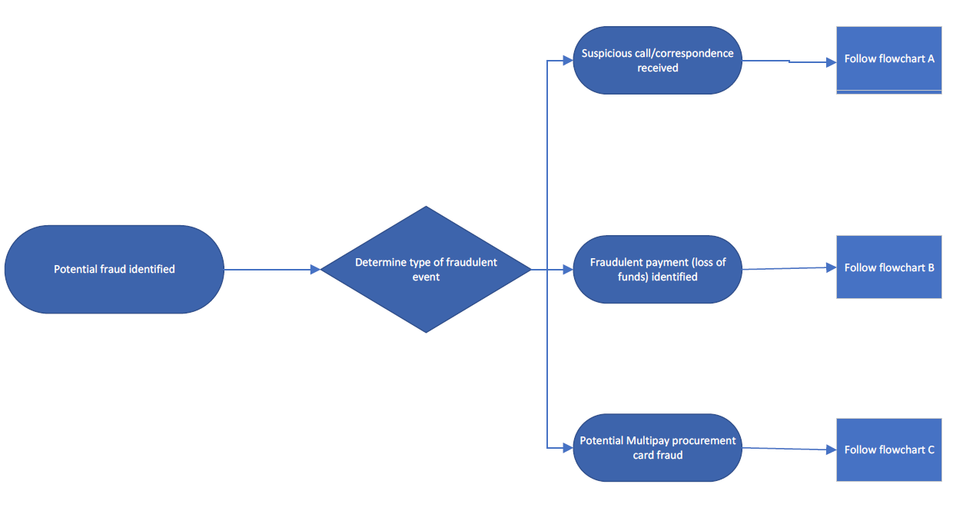Appendix – flowcharts

Appendix A

Appendix B – Fraud flow chart

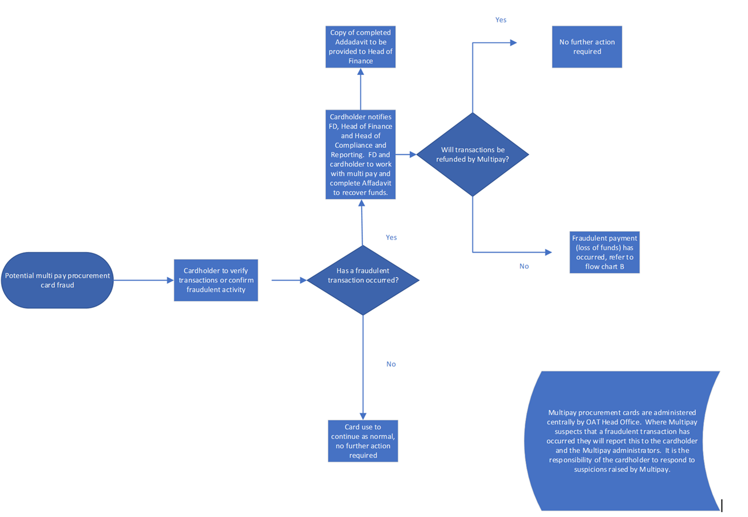Appendix C – Procurement card flow chart